BOARD OF ASSESSORS
REGULAR MEETING AGENDA
June 21, 2021 @ 4:00 PM

Review and vote to approve audio conference meeting minutes from May 10, 2021

Motor Vehicle:

Vote to approve twenty-one + abatement applications

Vote to approve May’s monthly list of abatements for 2019 $1,951.25

Vote to approve May’s monthly list of abatements for 2020 $314.25

Vote to approve May’s monthly list of abatements for 2021 $3,152.64

Vote to approve the commitment and warrant for 2021-02 $327,145.37

Vote to approve a recommitment and warrant for 2007, 2008 & 2009 $700.82
Real Estate & Personal Property:
The Omitted and Revised Assessment Report for FY22 was entered in DOR’s Gateway
Vote to approve the FY22 Preliminary Tax commitment and warrant for the following;
- Real Estate $8,407,724.61
- Stiles $126,082.53
- Personal Property $371,929.30

Old Business:

Nothing at this time

New Business:

Anything else that may arise prior to our scheduled meeting time
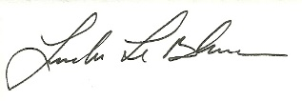
Linda LeBlanc, MAA

