Board of Assessors

Memorial Town Hall

157 Main Street Tel: 508-885-7500 x 165

Spencer, MA 01562 Fax: 508-885-7512

BOARD OF ASSESSORS MEETING AGENDA
April 16, 2020 @ 5:30 PM
Audio Conference

Motor Vehicle:
Vote to approve the commitment and warrant for 2020-02. $185,579.65

Old Business:
None at this time

New Business:

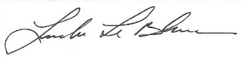
None at this time
Linda LeBlanc, MAA

