BOARD OF ASSESSORS
REGULAR MEETING AGENDA
April 11, 2022 @ 4:00 PM

Review and vote to approve meeting minutes from March 14, 2022
Next meeting is scheduled for May 9, 2022
Motor Vehicle:

Vote to approve 47+ abatement applications

Vote to approve March’s monthly list of abatements for 2019 $103.64

Vote to approve March’s monthly list of abatements for 2021 $47.49

Vote to approve March’s monthly list of abatements for 2022 $25,069.16

Vote to approve Commitment and Warrant for 2022-02 $192,132.15

Vote to approve Recommitment and Warrant for Tax Collector 1991, 1999, 2000 & 2011 $456.66
Real Estate & Personal Property:
Vote to approve March’s monthly list of exemptions and abatements $1,293.03

Old Business:

Nothing currently

New Business:

The following FY22 DOR Gateway misc. forms for reimbursement were submitted on 4/5/22;

MDM-1

Veterans Exemptions

MVE Reimbursement

Paraplegic

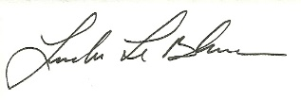
Linda LeBlanc, MAA

