BOARD OF ASSESSORS
REGULAR MEETING AGENDA
August 8, 2022 @ 4:00 PM

Review and vote to approve meeting minutes from July 11, 2022
Next meeting is scheduled for September 13, 2022
Motor Vehicle:

Vote to approve 14 abatement applications

Vote to approve July’s monthly list of abatements for 2022 $2,292.34

RECAP:

Sign the LA-13A Amended new growth form in Gateway
Old Business:
Nothing at this time

New Business:

Anything else that may arise from the agenda posting to the meeting time

Executive Session:
The Board needs to enter executive session G.L. c. 30A, §21 (a) purpose 7 - To comply with, or act under the authority of, any general or special law or federal grant-in-aid requirements, citing the

statutory right to privacy to discuss Applications for Statutory Exemptions (Ch 59 § 60).

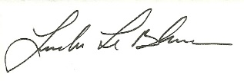
Linda LeBlanc, MAA

