BOARD OF ASSESSORS
MINUTES OF MEETING
May 8, 2023 @ 4:00 PM

Members Present: Pam Woodbury, Nancy Herholz & Robert Ortiz
Principal Assessor, Linda LeBlanc
Meeting called to order @ 4:05 pm
Our next Board Meeting will be held on Monday, June 12th @ 4:00 pm
The Board voted to approve the minutes for April 10, 2023 Vote (3-0)

Real Estate: Vote (3-0)
The Board voted to approve April’s monthly list of exemptions for FY23 $400.00

Motor Vehicle: Vote (3-0)

The Board voted to approve 67 abatement applications

The Board voted to approve April’s monthly list of abatements for 2022 $2,006.03

The Board voted to approve April’s monthly list of abatements for 2023 $17,630.92

The Board voted to approve warrant and recommitment for 2005 & 2006 bills for Tax Collector $90.00

Boat Excise: Vote (3-0)

The Board voted to approve April’s monthly list of Boat Excise abatements $65.00

Department of Revenue:

The DOR approved the MDM-1 form and the Veterans Exemption form for FY23

Appellate Tax Board:

The Board was informed of the upcoming hearings to be held by Zoom on May 22nd

Old Business & New Business:

The meeting was adjourned at 4:35pm.

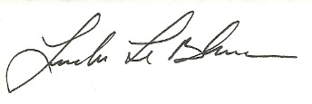
Linda LeBlanc, MAA

