BOARD OF ASSESSORS
REGULAR MEETING AGENDA
May 9, 2022 @ 4:00 PM

Review and vote to approve meeting minutes from April 11, 2022
Next meeting is scheduled for June 13, 2022
Motor Vehicle:

Vote to approve 57+ abatement applications

Vote to approve March’s monthly list of abatements for 2021 $360.97

Vote to approve March’s monthly list of abatements for 2022 $4,005.84

Old Business:

Nothing currently

New Business:

Anything else that may arise from the agenda posting to the meeting time

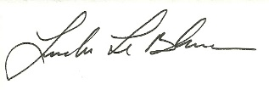
Linda LeBlanc, MAA

